Wireframe Document

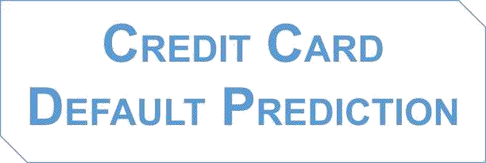

**Submitted by:**

Suchindra Kumar

**HOME PAGE**

"Welcome to Credit Card Default Prediction" is a project created by Suchindra Kumar. This project aims to predict credit card default behavior using machine learning algorithms. By clicking the button below, users can proceed to the prediction interface where they input relevant data, such as demographic information, credit history, and payment behavior. The predictive model then processes this data to provide insights into the likelihood of a credit card default occurring in the future. This project serves as a valuable tool for individuals and financial institutions seeking to assess and manage credit risk effectively.

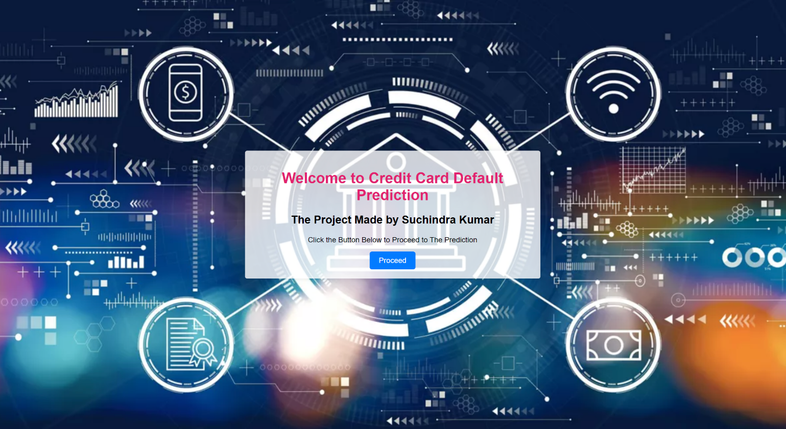

**PREDICTION FORM**

Banks can enter details into this window of the Prediction Form. To Predict if The Customer will Default next Month or Not?

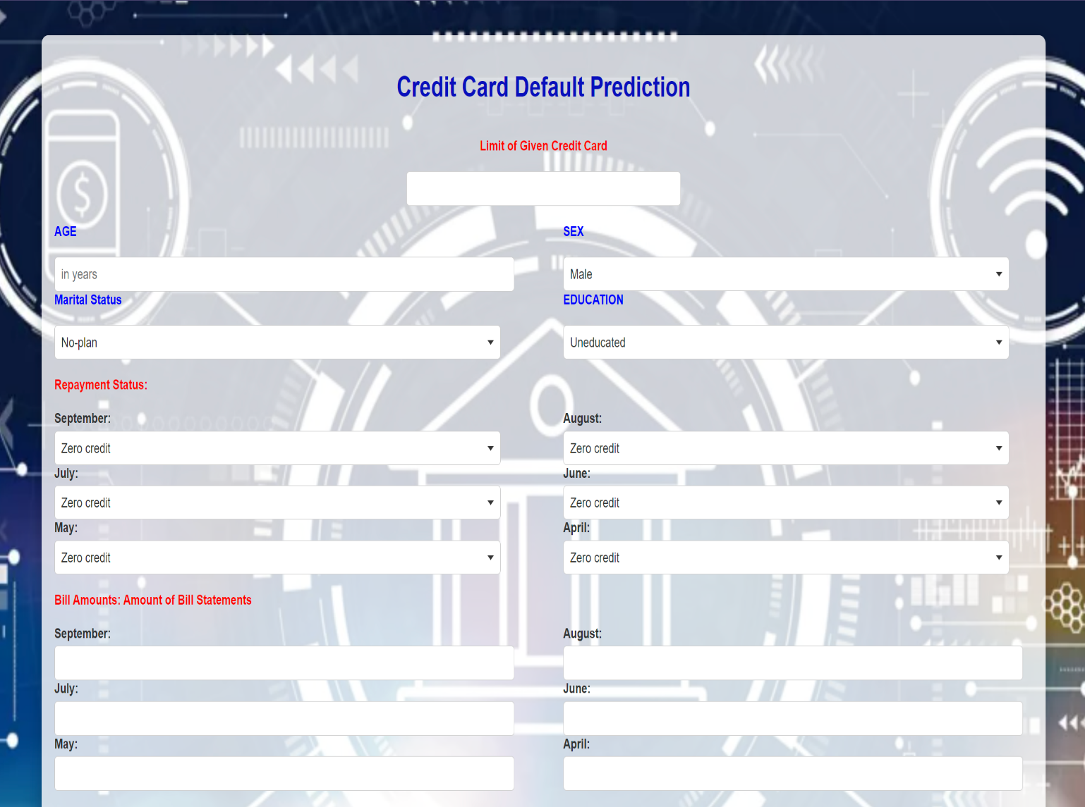

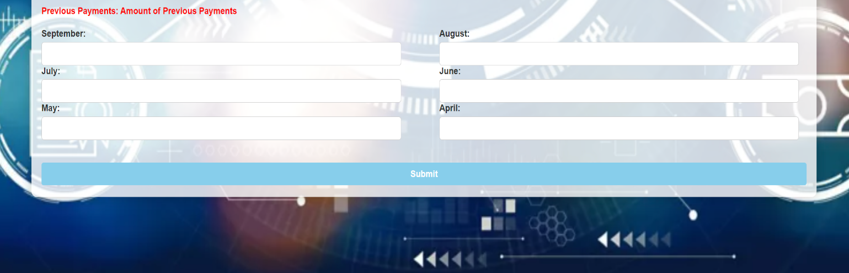

**RESULT PAGE**

This Page will display the result of the requested product. A Sample View of Showing Results is Below



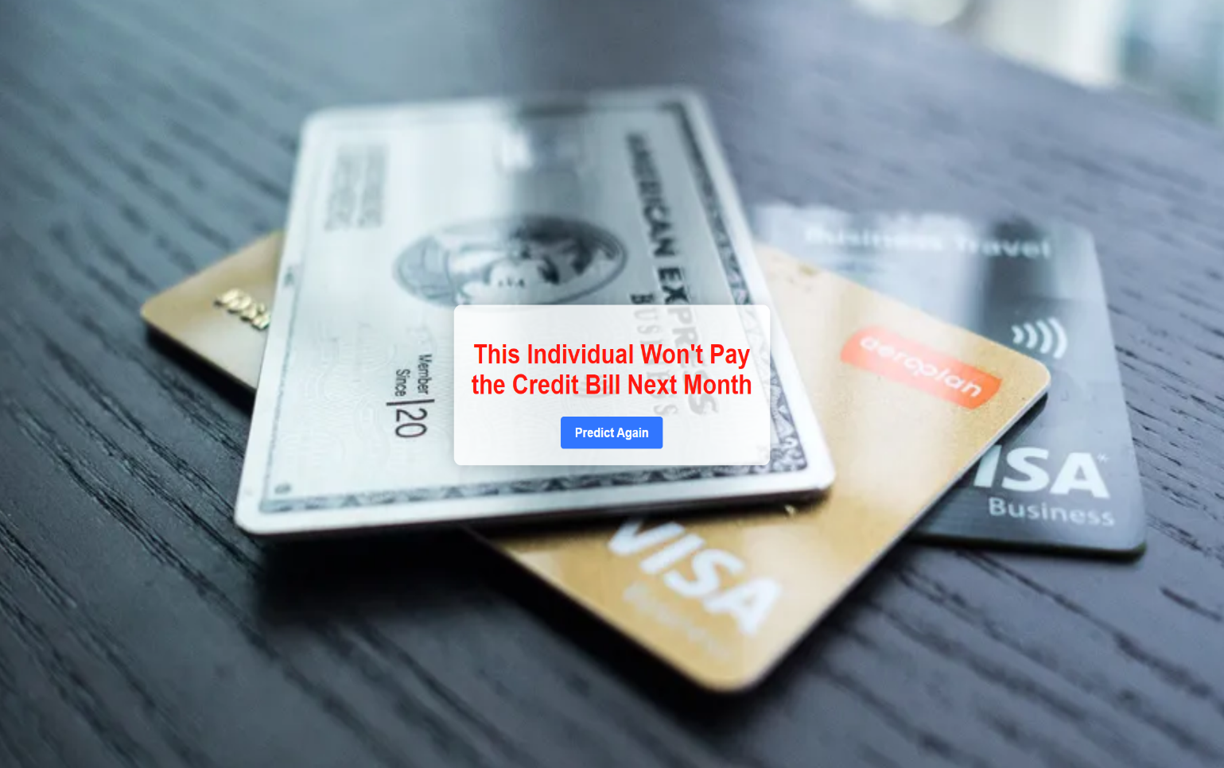

**Combined view of input and output window for the credit card default prediction system, Based on User’s input, credit card default prediction System showing The results.**